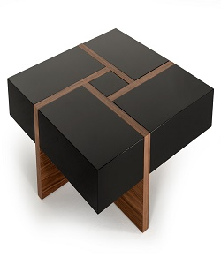

Modern Coffee table

$58.82

Availability: In stock

**Description:**

Modern black coffee table with wood stand. A clear striped glossy top provides a place for any items you want to show off, while boxy sled-style base below sports a sleek metallic finish for an on-tred look.this narrow design is perfect look for living room.Assembly is required.